**DBMS REPORT**

**S Gokul (RA2211003011996)**

**Ex. No. 2 Working with data manipulation commands**

1)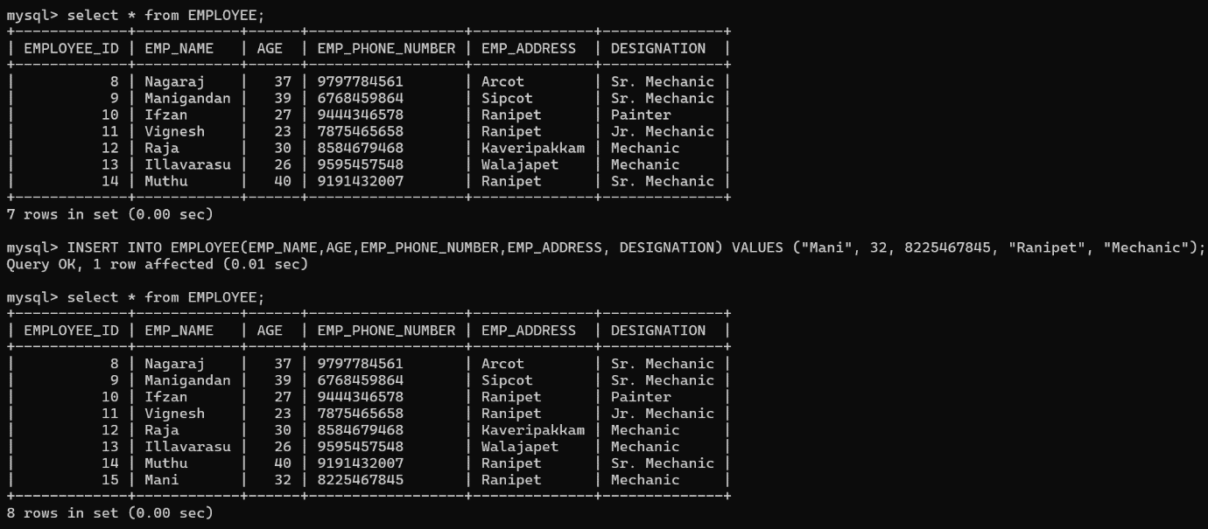

2)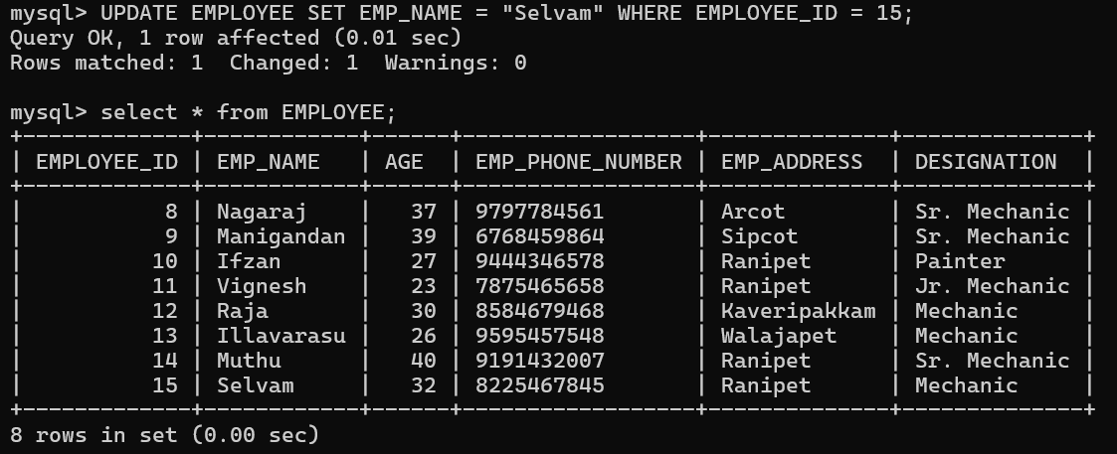

3)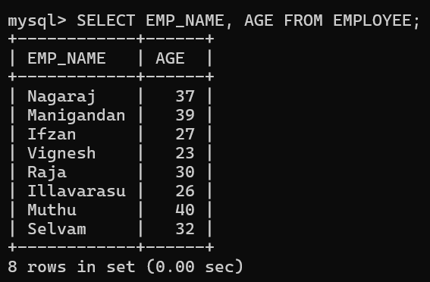

4)



**Ex. No 3 Integrity Constraints**

1)

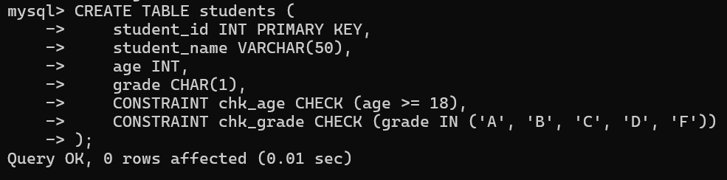

2)

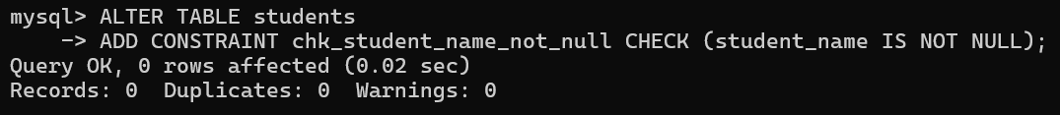

**Ex. No. 4 Basic select statements**

1)

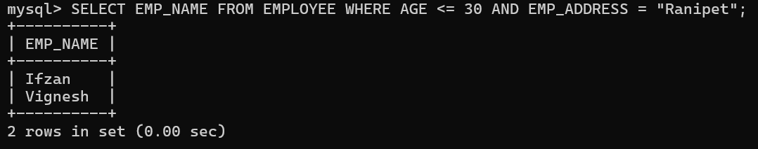

2)

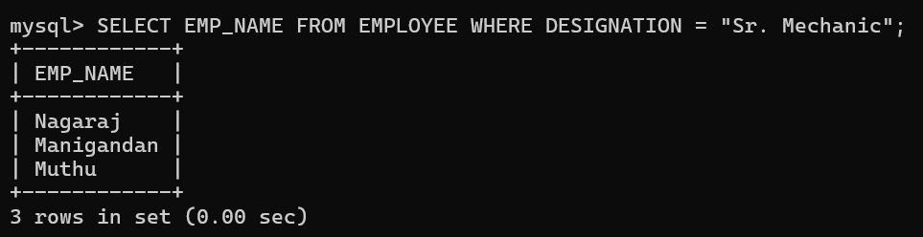

3)

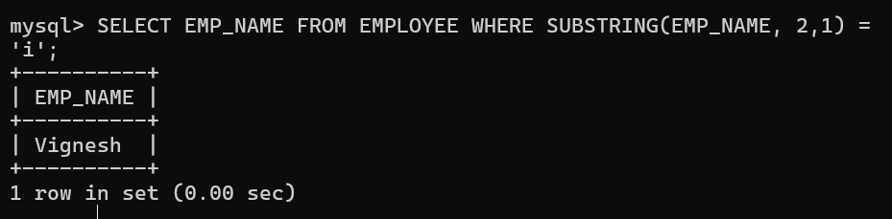

**11) Basics of PL/SQL**

1. **Trigger**

